Live Chat — Bot Manipulation / Stored XSS / CSRF
Proof of Concept Report — HackViser Lab
Prepared by: Aakash Singh | Date: May 31, 2026

Vulnerability Information

Author | Aakash Singh
Date | May 31, 2026
Lab | Live Chat — Bot Manipulation / Stored XSS / CSRF
Platform | HackViser
Vulnerability Type | Bot Manipulation via Malicious URL in Live Chat
Severity | High
CWE | CWE-79 / CWE-352
Impact
An attacker can inject a malicious URL into the live chat to manipulate the support bot into performing unauthorized actions such as changing the admin password, leading to full account takeover.
Reproduction Steps
Step 1: Log in and navigate to the Live Chat feature of the application.
Step 2: Confirm the request is a GET with 200 OK status using Burp HTTP history.
Step 3: Craft a malicious URL that triggers a password change action when visited.
Step 4: Send the malicious URL in the Live Chat — the support bot follows the link.
Step 5: Bot executes the password change action for the admin account.
Step 6: Log in using the new admin credentials.
Step 7: Retrieve the CTF token from the admin session.
Evidence Screenshots
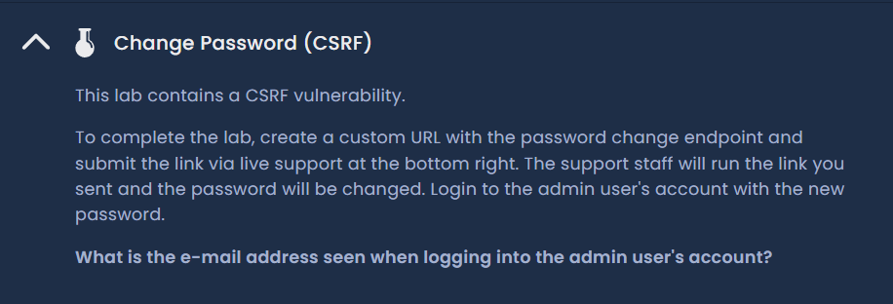
Figure 1: Live Chat page — initial state
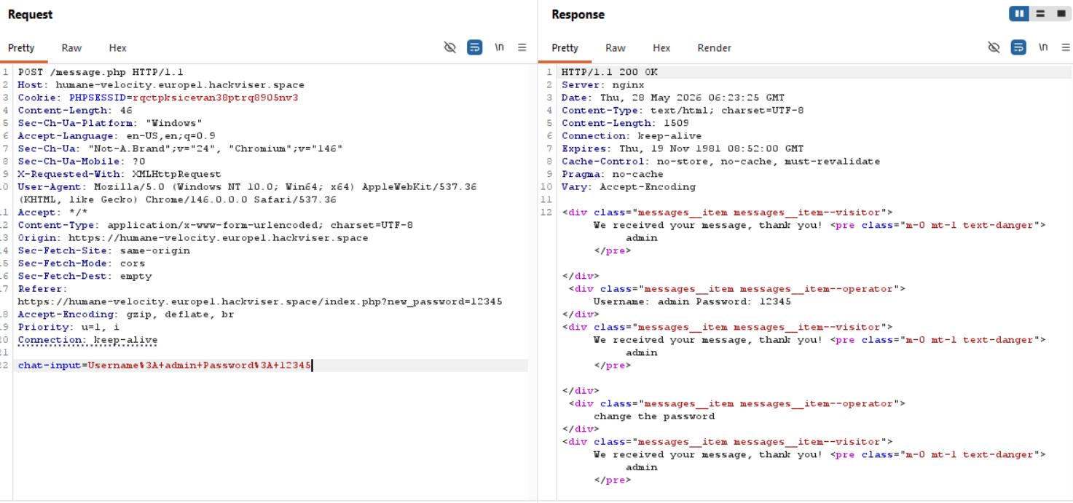
Figure 2: GET request confirmed — 200 OK in HTTP history
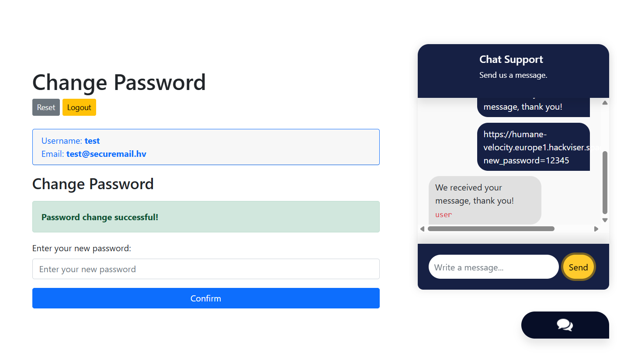
Figure 3: Malicious URL sent in Live Chat — bot manipulation in progress
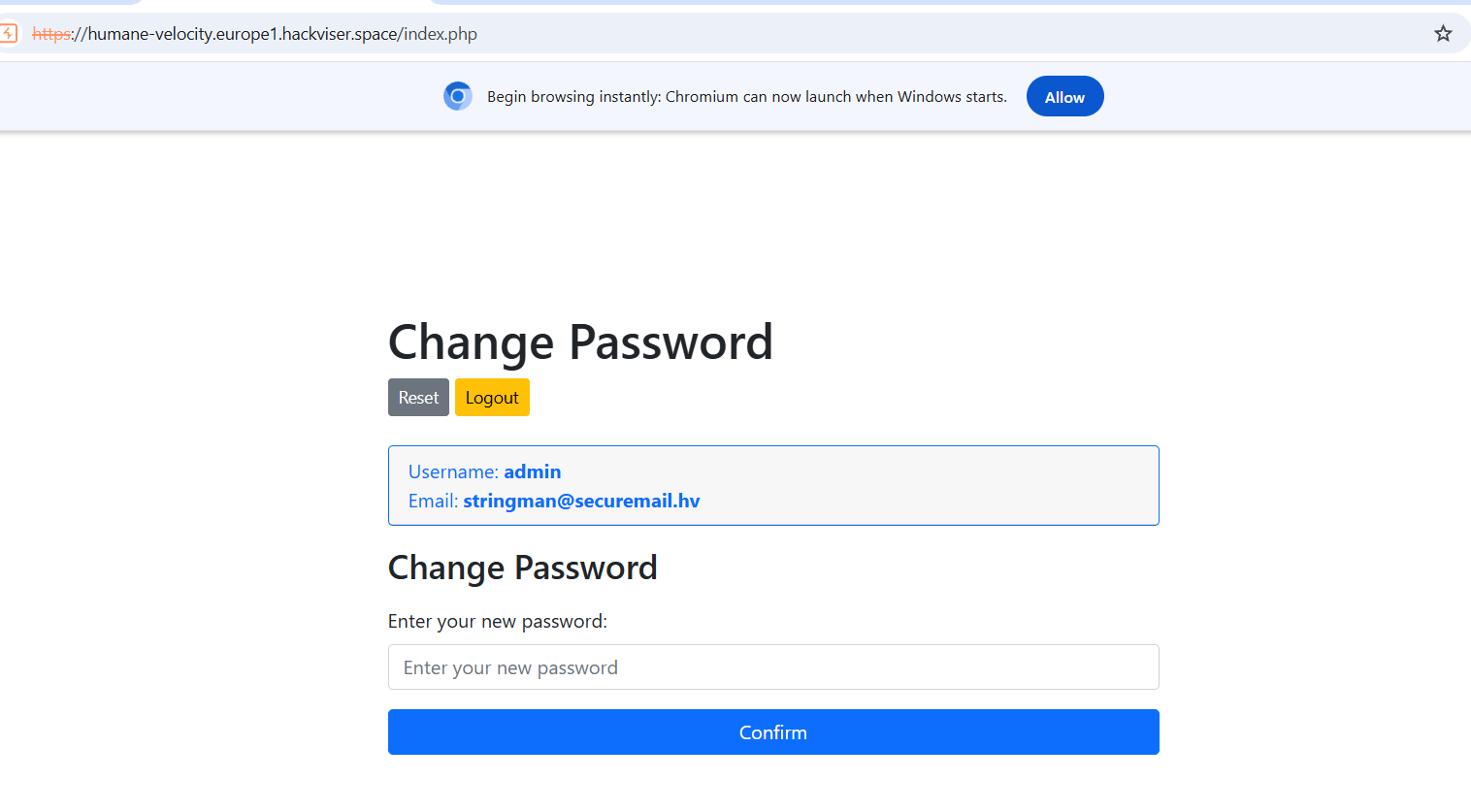
Figure 4: Password changed — admin credentials updated
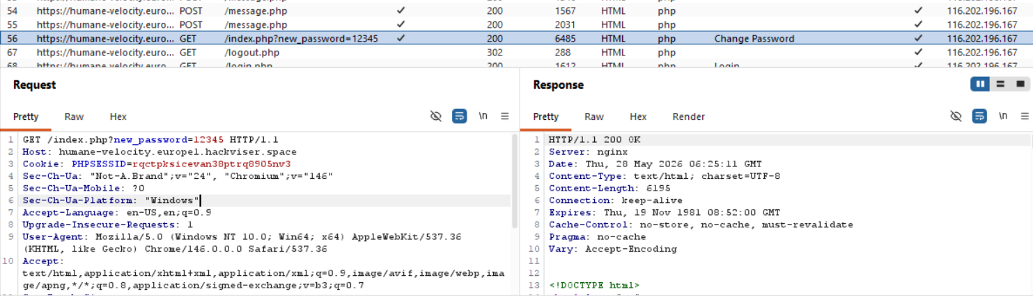
Figure 5: Request found in HTTP history post-exploit
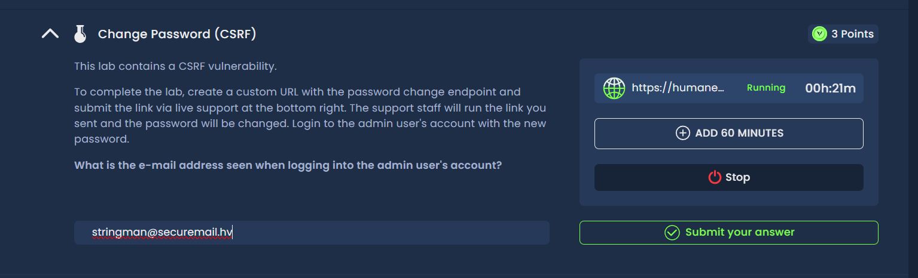
Figure 6: CTF token retrieved — lab solved
Remediation
Sanitize and validate all URLs received through chat interfaces. Implement CSRF tokens on sensitive actions. Ensure bots do not blindly follow user-provided links.
Confidential — Prepared by Aakash Singh | Security Research POC

